**Mobility Data Dashboard submission form.**

Submit your project using this document and **include screen shots** of each step with the **command window showing your physical address in the same screen shot**. Use the C:\>**getmac** command to display your physical address.

My laptop physical address is **18-1D-EA-8B-9F-BF**

1. Open the MobData.txt file and import into excel to prepare and clean the data if necessary. You can use notepad, excel or Cognos for this step. Once you have finished preparing the data save your file as **mob####.CSV replacing #### with the last 4 digits of your student number**. Explain how you prepared or cleaned the data and was it necessary?

**Ans**.

As the file was clumsy having dictionary data it was not easy to understand. Moreover, it was not in tabular format which is accepted when doing data analysis. So first I need to massage the data set using notepad ++

**Step1**: Copied data to Notepad++ and by using Ctrl+F (Find and replace option) replaced ‘}’ with /n so that all the rows data converted to column (stacked one below other).Removed unnecessary sentence “Dorchester Road and Huron Church Road” and made data ready for analysis by doing following steps.

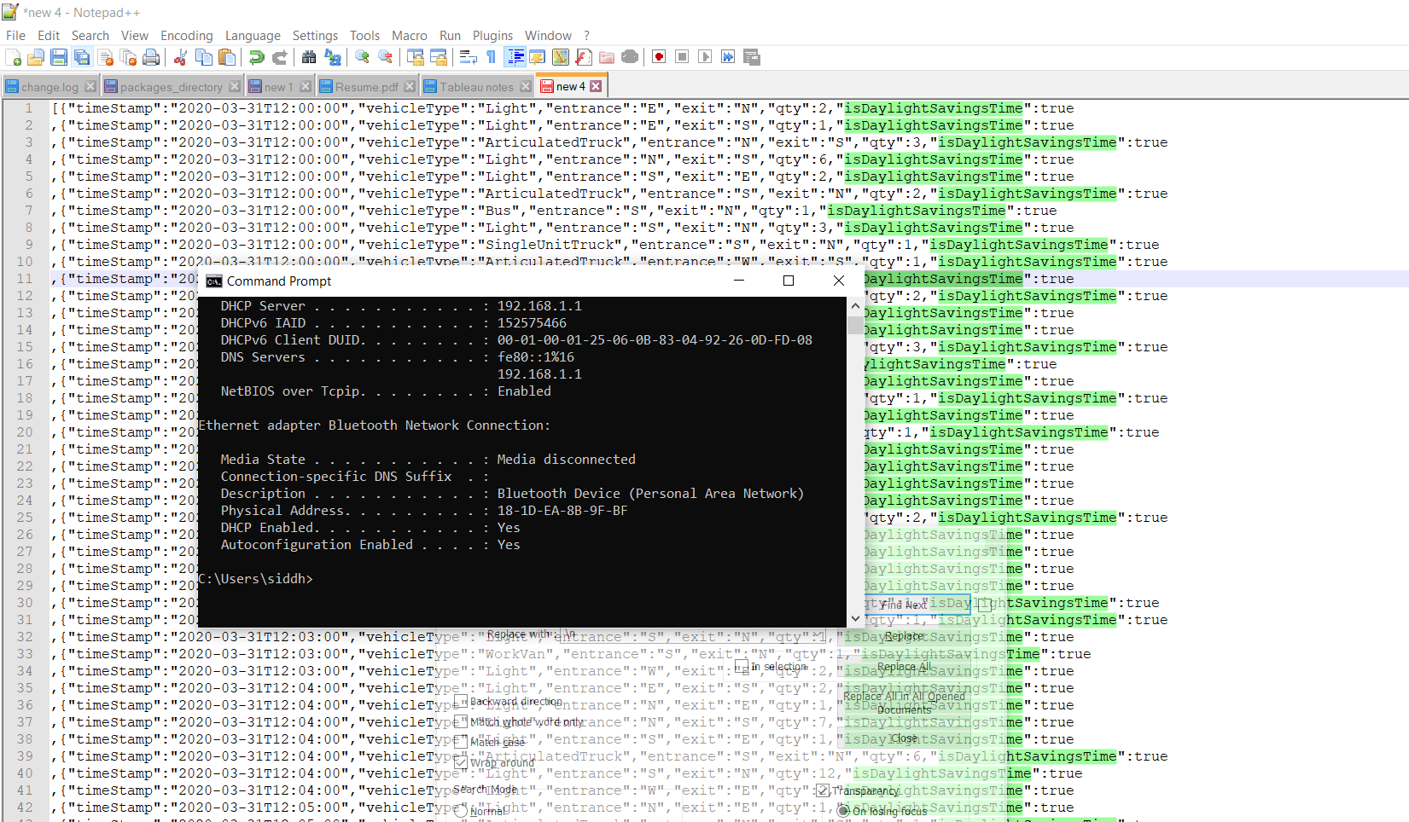

**Step2:** Removed Column names (field names) which was repeated multiple times using find and replace with ‘ ’.

**Step 3:** Removed repeated column name and noted their position .and then added the column name in python code at once.

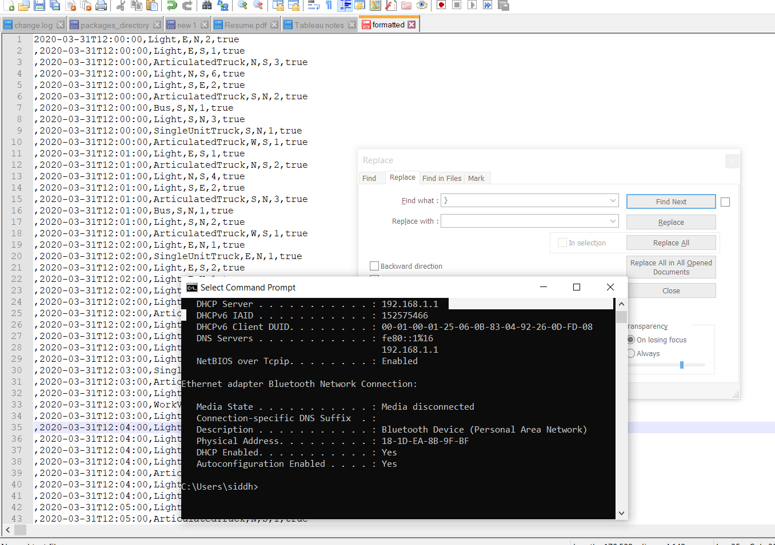

**Step3**: Converted Text File into Mob.CSV using Python Code. I created a Python code which will read the frmt_W0747944.Txt file and write by creating new file mob7944 .csv

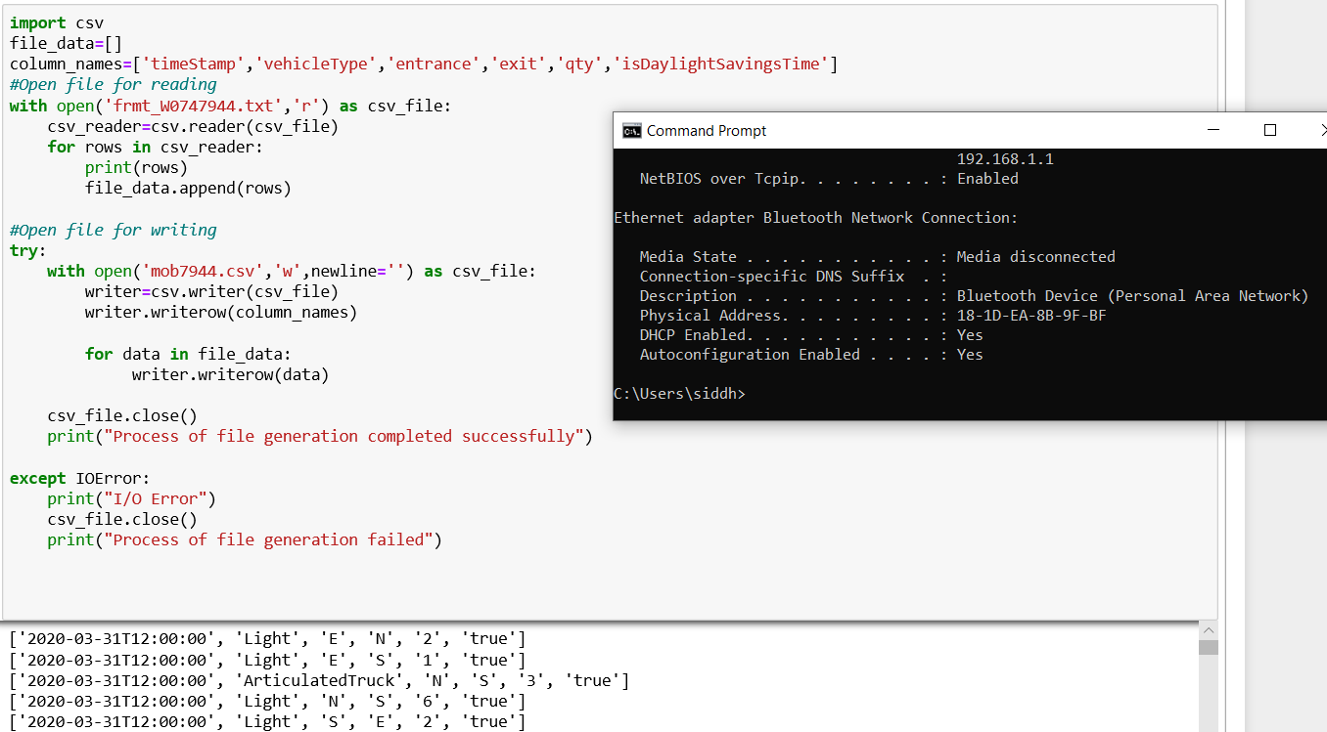

INPUT File -> Python Code -> Output File

 

It can also be converted to csv using excel by using text to columns option and then by separating delimiter by comma ( , ) in excel work book but in future if we have many files then this code will be more efficient than doing manually in excel.

1. Create a dashboard in Cognos using the CSV file you created in step 1. The dashboard should show a summary with different charts using the columns below. The dashboard should clearly display what are the most common types of vehicles, when is traffic the heaviest and whatdirection are vehicles travelling. Save your dashboard as **MobDashboard####** **replacing #### with the last 4 digits of your student number**. What steps did you use to create the dashboard?
   1. timestamp
   2. vehicleType
   3. entrance
   4. exit
   5. qty

First, I imported the mob7944.csv file in Cognos using browse option and then by double clicking on the file. It prompted me dashboard layout then I selected tabbed one and then started visualization.

**Step 1)**

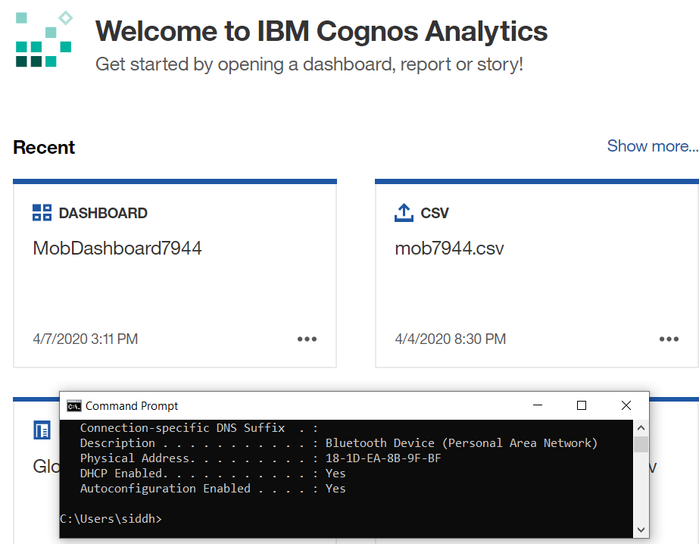

**Step 2)**

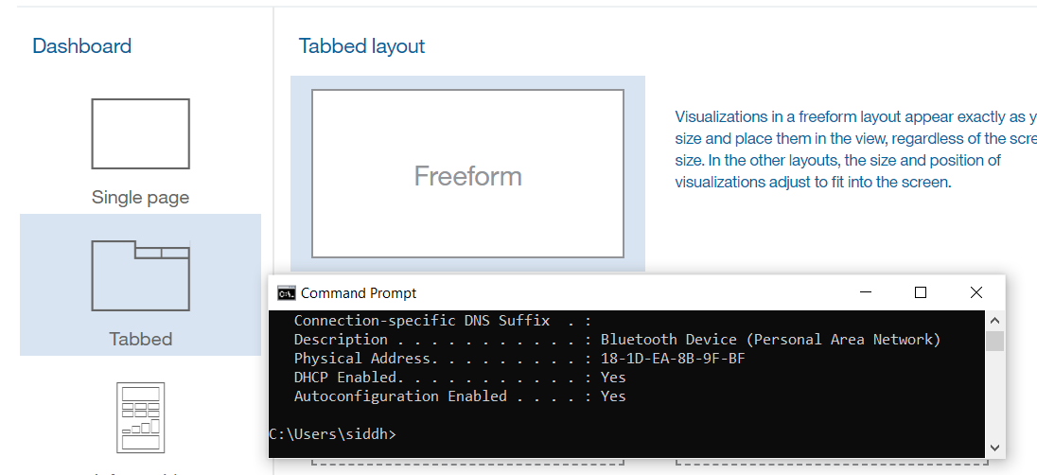s

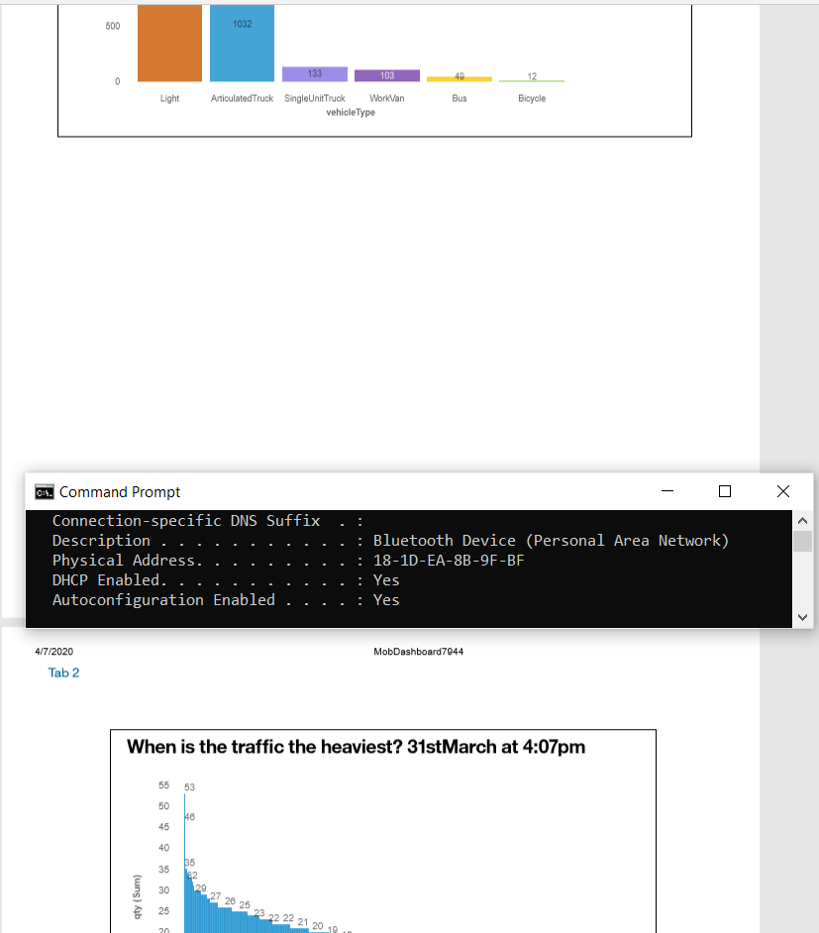

All the visualization can be seen in pdf attached below.



1. **Export your dashboard as a pdf and submit the file using the assignment link. Save the file as Mob Dashboard####.pdf. What steps did you use to export the file?**

**Step1.**First I clicked on edit preview option and then I clicked on three dots to export to pdf

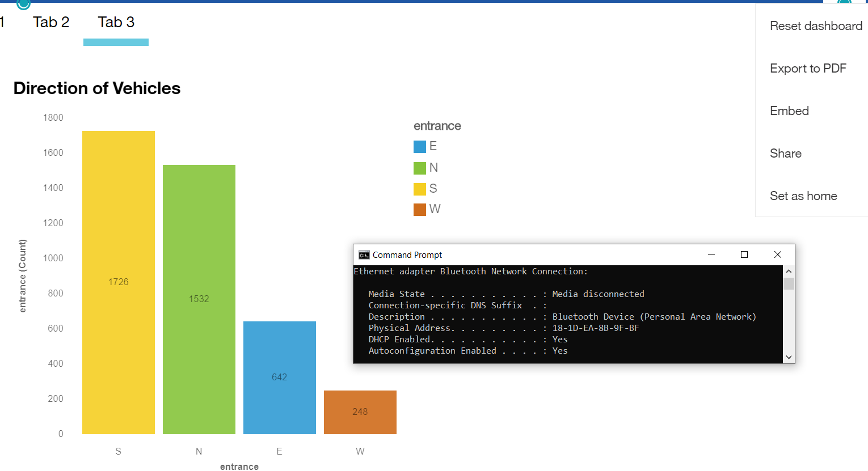

**Step2:** Second I selected page size to letter and Orientation to Landscape

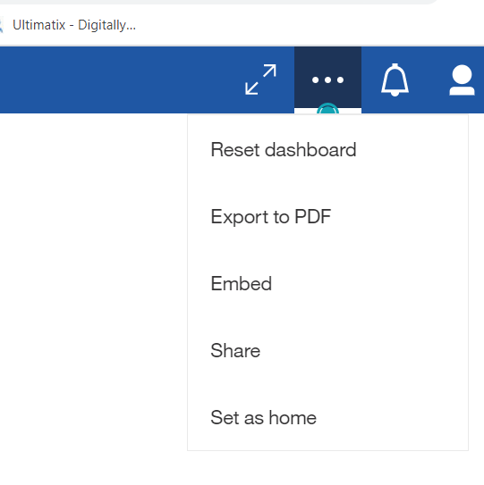

**Ans.** From above visualization we conclude that

* Most of the time **light** vehicle drives in this intersection.
* Heaviest traffic was observed on **31st March at 4:07pm**.
* Most of the vehicle enter and leave the direction in **south** direction.



1. **BONUS: This step is optional and will be worth and additional 5%**. Create a new Dashboard by using the open traffic data from March 13 to 27. Use the instructions below on how to access the open traffic data from an intersection. The dashboard must use all the data from March 13 to 27 and provide summary details on the type of traffic and volume for the period. Grades will be determined based on the amount of details and insights provided in the dashboard report.
   1. **Submit your csv file with all traffic data as Bonus_mobdata####**.**csv** (replacing #### with the last 4 digits of your student number)
   2. Submit the exported copy of your dashboard as a pdf. **Save the file as BonusMobdasboad####.pdf** (replacing #### with the last 4 digits of your student number)
   3. Provide a screen shot of your completed project in Cognos on your laptop with your physical address showing in the same window.

**Ans**.

a) **Bonus_mob7944.Csv** b) **BonusMobdashboard7944.pdf**

 

**Steps followed while preparing project**

* Went to <https://opendata.citywindsor.ca/swagger> and extracted traffic data from the period 13th march to 21st March.
* Cleaned the data using Notepad++ and made csv consumable format.
* Developed Python Code which will read data from multiple txt files and write it in .Csv file.
* Created additional date column in Bonus_mobdata7944 file.csv by truncating date from time stamp using formula =left(cellnum,10) and populated it across the entire column.
* Imported the dataset in Cognos
* Created new dashboard based on this dataset for visualization.

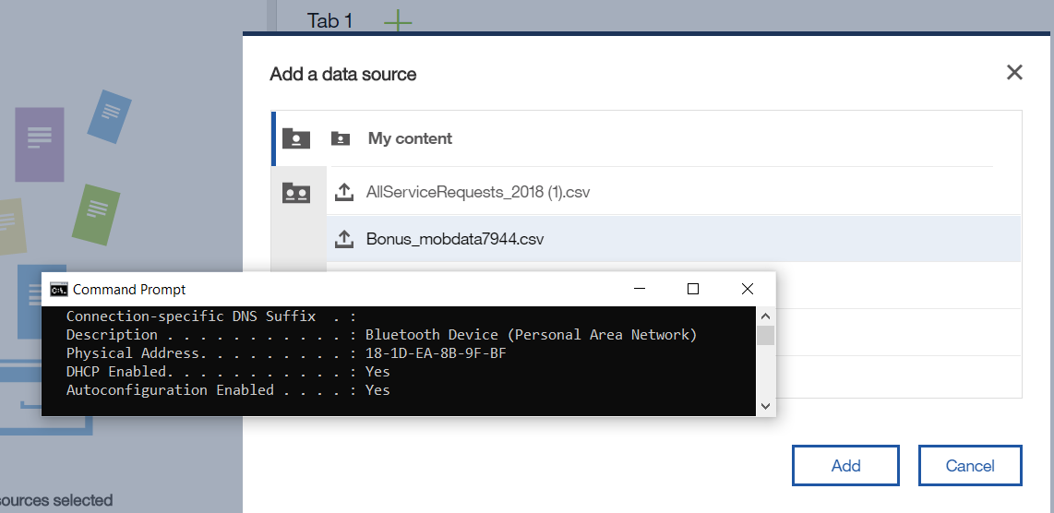

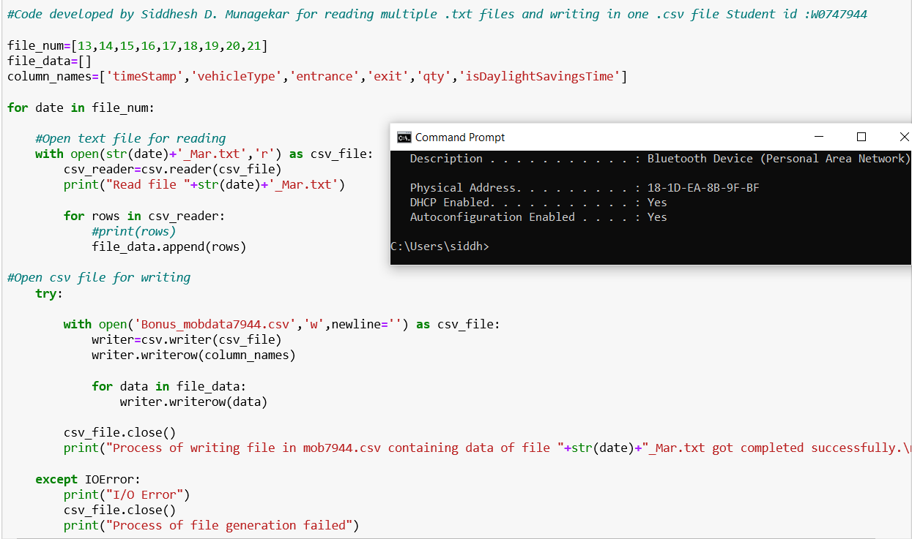

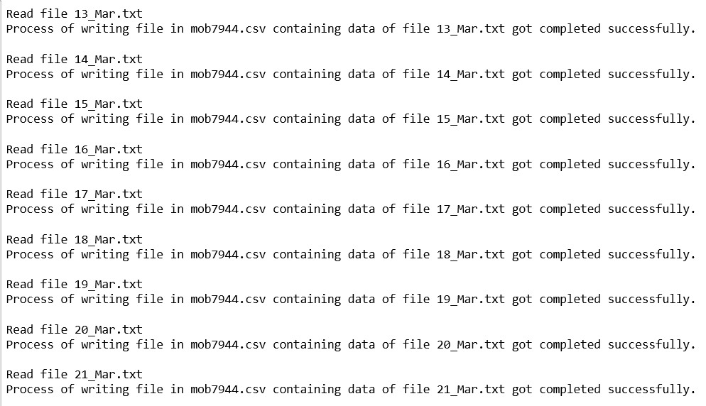



After processing the data in single csv file ,I created one new column Date containing only date values removing time stamp this I have achieved by implementing left truncation formula on excel cell as =left(A2,10) .and then dragged all the formula to the entire row.

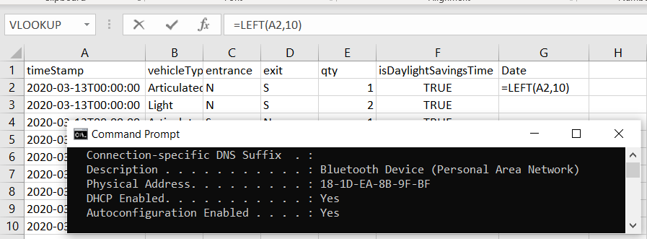

This date column is used in visualization to see type and quantity of traffic across the period from 13 Mar to 21 Mar.

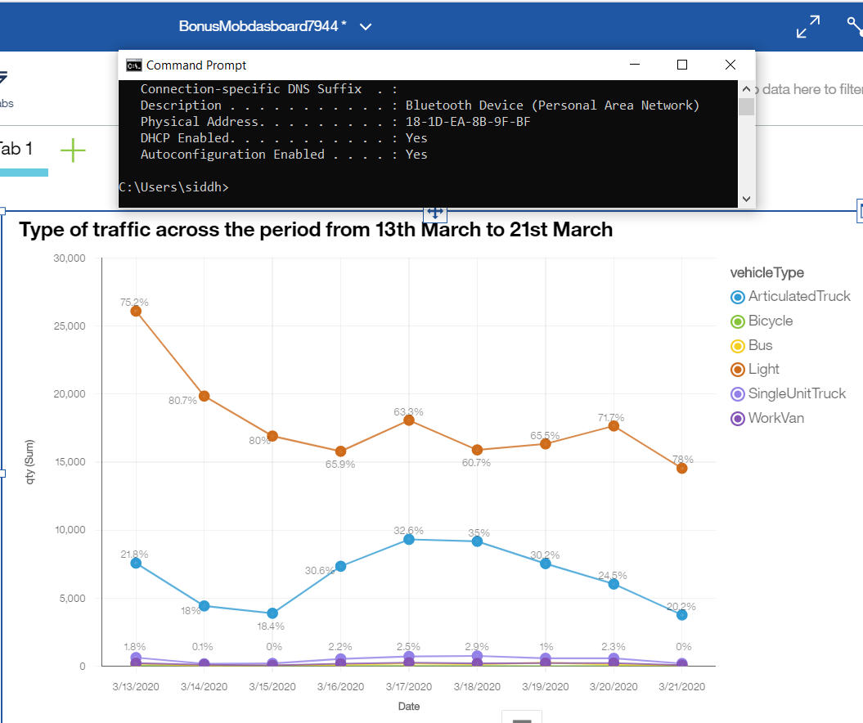

% values represent vehicle type (category) %, which are contributing to the total traffic for a day seen in vertical direction.

As we can see that traffic decreases drastically from 13th March to 21st March might be due to corona virus Lockdown.

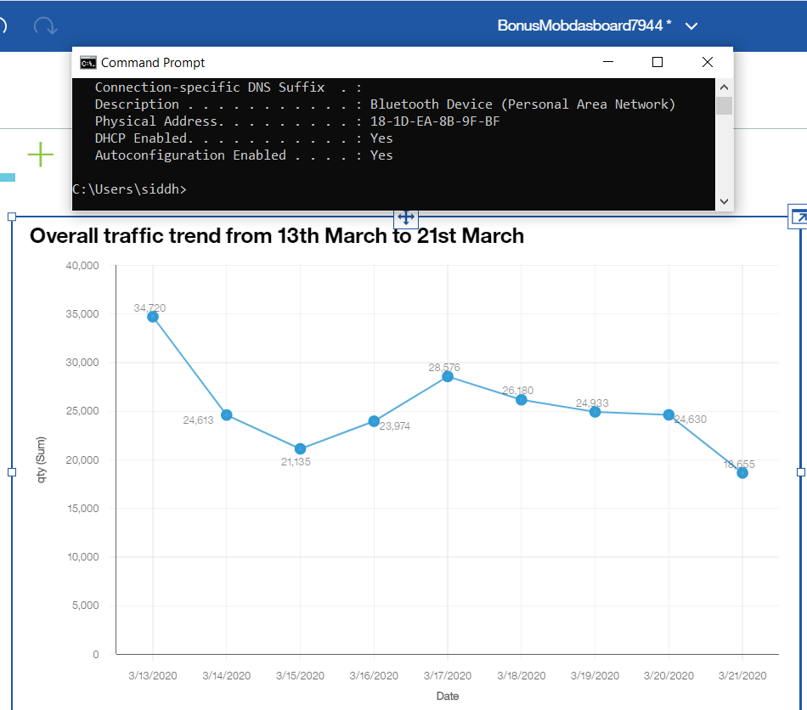

This is the overall decrease in traffic from 13th March to 21st March as there can be reason that people became more cautious due to outbreak of Covid-19.

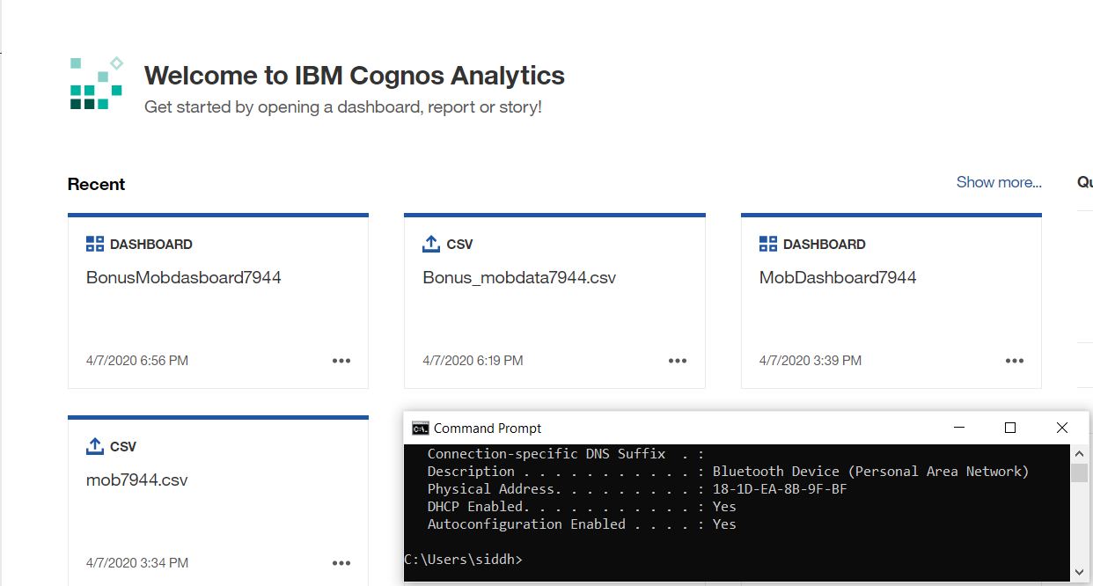

**How to access the open traffic data from an intersection**

At the top of our Open Data page <https://opendata.citywindsor.ca/> we have a link to JSON data (there is too much traffic data to expect people to download it in a file and find it useful)

We are presenting it using a free, open-source tool called swagger

<https://opendata.citywindsor.ca/swagger>

This shows a user how to make a web request that returns the data they ask for, like <https://opendata.citywindsor.ca/api/traffic?intersectionId=1&start_time=17%3A00>

Which returns:

{

  "intersectionId": 1,

  "intersectionDescription": "Dorchester Road and Huron Church Road",

  "traffic": [

    {

      "timeStamp": "2020-02-25T17:00:00",

      "vehicleType": "Light",

      "entrance": "E",

      "exit": "N",

      "qty": 1,

      "isDaylightSavingsTime": false

    },

    {

      "timeStamp": "2020-02-25T17:00:00",

      "vehicleType": "Light",

      "entrance": "E",

      "exit": "S",

      "qty": 5,

      "isDaylightSavingsTime": false

    },

Etc...

